National Event Management Service (NEMS) Onboarding Guide

V1.1 December 2020

Document Management

Revision History

|  |  |  |  |
| --- | --- | --- | --- |
| Version | Date | Author | Summary of Changes |
| v0.4 | 10/08/2020 | James Lane | Updates:   * Details of the NEMS assurance stages * Elaborates TKW meaning * Updated contact details – route of entry * Further details – TKW/INT testing requirements |
| v0.5 | 21/08/2020 | James Lane | Updated following review – grammatical changes |
| V1.0 | 28/08/2020 | James Lane | Updated with approval – processes in appendices changed to attachments |
| V1.1 | 17/11/2020 | James Lane | Cosmetic changes based on feedback, additions to NEMS Assurance Stages to mirror format of NRL onboarding guide, clarity of Catbag codes, INT environment connection section updated, failover issue addressed. |

Reviewers

This document has been reviewed by the following people:

| Reviewer Name | Title / Responsibility | Date | Version |
| --- | --- | --- | --- |
| Raman Behl | NEMS / NRL Clinical Lead | 25/08/2020 | v1.0 |
| Andy Quinn | NEMS Project Manager | 25/08/2020 | v1.0 |
| James Cox | NEMS Technical Architect | 25/08/2020 | v1.0 |
| Rebecca Thirsk | Principal Business Analysis Manager | 25/08/2020 | v1.0 |
| Rebecca Snape | NEMS / NRL Product Manager | 25/08/2020 | v1.0 |
| Shail Ravjibhai | DCH Business Analysis Manager | 25/08/2020 | v1.0 |

Approved by

This document must be approved by the following people / boards:

| Name | Signature | Title | Date | Version |
| --- | --- | --- | --- | --- |
| Gemma Beacock |  | NEMS / NRL Product Owner | 28/08/2020 | v1.0 |

Glossary of Terms

| Term / Abbreviation | What it stands for |
| --- | --- |
| AIDA | Applications and Infrastructure Design Authority |
| API | Application Programming Interface |
| ASID | Accredited System ID |
| BIDA | Business Interoperability Design Authority |
| CDA | Cyber Design Authority |
| DCH | Digital Child Health |
| DDA | Data Design Authority |
| DHSC | Department of Health and Social Care |
| DIP | Digital Interoperability Platform |
| DPIA | Data Protection Impact Assessment |
| DVP | Deployment Verification Period |
| FHIR | Fast Healthcare Interoperability Resources |
| HSCN | Health and Social Care Network |
| IG | Information Governance |
| IopS | Interoperability Standards |
| ITK | Interoperability Toolkit Standards |
| IWG | Interoperability Working Group |
| LHCR | Local Health Care Record |
| MESH | Message Exchange for Social Care and Health |
| N3 | NHS Secure National Broadband |
| NEMS | National Event Management Service |
| NHS | National Health Service |
| NHSD | NHS Digital |
| NRL | National Record Locator |
| NWR | New Work Request |
| ODS | Organisation Data Service |
| PDS | Person Demographic Service |
| PHE | Public Health England |
| RBAC | Role Based Access Control |
| SCAL | Supplier Conformance Assessment List |
| TCC | Technical Conformance Certificate |
| TKW | Toolkit Workbench |
| TRG | Technical Review and Governance |

Document Control:

The controlled copy of this document is maintained in the NHSD corporate network. Any copies of this document held outside of that area, in whatever format (e.g. paper, email attachment), are considered to have passed out of control and should be checked for currency and validity.

Contents

1 Introduction 7

1.1 Document Purpose 8

1.2 Audience 8

2 National Event Management Service 9

2.1 Overview 9

2.1.1 NEMS Vision 9

2.1.2 Publish / Subscribe Pattern 9

2.2 NEMS Data Flow 10

2.3 NEMS Eligibility 10

2.4 NEMS Principles 11

2.5 NEMS Prerequisites 11

3 NEMS Functionality 13

3.1 Overview 13

3.2 Generic Event Messages 13

3.2.1 Event Maturity 14

3.2.2 Supported Generic Event Messages 14

3.2.3 Digital Child Health Event Messages 15

3.3 Publishing 15

3.4 Subscribing 15

3.5 Subscriptions Management 16

3.5.1 Explicit Subscriptions 16

3.5.2 Rule-Based (Generic) Subscriptions 17

4 Testing and Technical Conformance 19

4.1 Technical Conformance Testing Guidance 19

4.2 NEMS Assurance Stages 19

4.3 Connecting to the NHS Digital Integration (INT) Environment 21

4.3.1 Instructions for End Point Registration (EPR) in the INT environment 21

4.3.2 INT Environment Connection Details for NEMS 22

5 Onboarding Artefacts 23

5.1 Supplier Conformance Assessment List and Technical Conformance Certificate 23

5.1.1 Already completed a SCAL? 24

5.2 Connection Agreement 24

5.3 Data Sharing Arrangement 24

6 Live Service Implementation 25

6.1 Live Connection Request 25

6.2 Supplier Access to NEMS Process 25

7 Post Implementation Support 26

7.1 Incident Management 27

7.2 Environment Maintenance 27

8 Appendix 29

8.1 NEMS Business Rules 29

8.1.1 PDS Birth Notification 29

8.1.2 PDS Change of Address 29

8.1.3 PDS Change of GP 29

8.1.4 PDS Death 29

8.1.5 Newborn Infant Physical Examination 29

8.1.6 Bloodspot Outcome 29

8.1.7 Hearing 29

8.1.8 Professional Contact 29

8.1.9 Vaccinations 30

8.2 NHS Digital Onboarding Supplier Task Checklist 31

8.3 Frequently Asked Questions 31

# Introduction

NHS Digital has been directed[1] and commissioned to develop IT applications, IT infrastructure and IT systems necessary to operate and deliver the Digital Interoperability Platform (DIP). The DIP underpins the delivery of a set of national integrated care capabilities and services to inform clinical decisions across all health and care settings and improve the experience of service users by enabling and enhancing the flow of patient information.

NHS Digital provides several national technical capabilities intended to help industry and local health and social care providers enhance interoperability between IT systems and to flow information to support direct care[2] purposes, one of which is the National Event Management Service (NEMS).

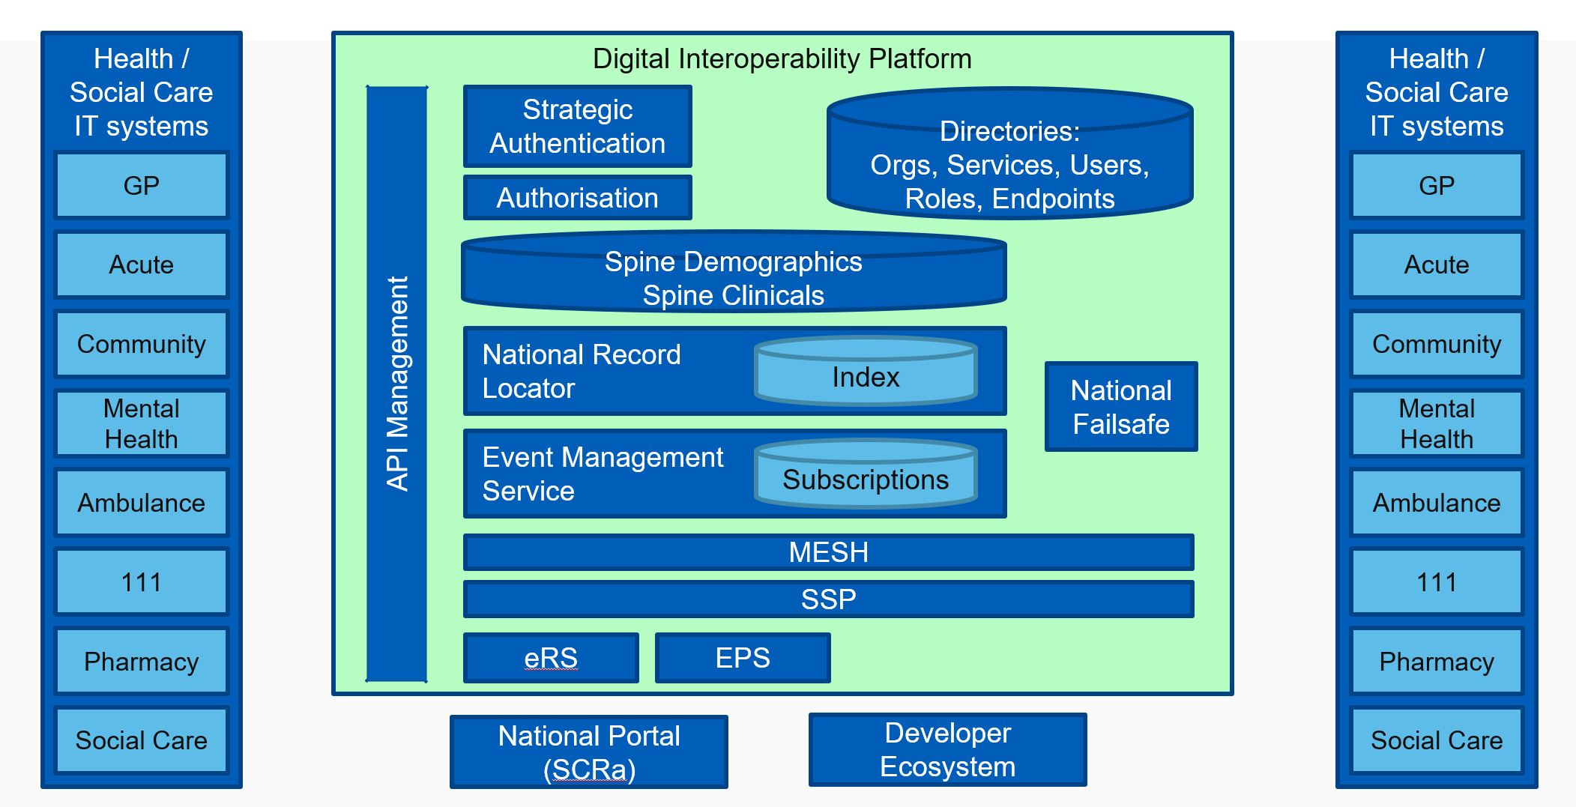

Figure 1: Digital Interoperability Platform

DIP patient information services bring together care information related to the patient in near real-time at the point of care and support wider sharing of records along care pathways and across organisational boundaries. In association, work is progressing to standardise integration through the development of application programming interface messages (APIs) and simplification of the operating model.

NHS Digital services which are enabled through the DIP include:

* GP Connect
* National Record Locator service (NRL)
* National Event Management Service (NEMS)
* Reasonable Adjustment Flag
* Summary Care Record application (SCRa)

## Document Purpose

This guide provides guidance for a health and social care organisation wishing to publish and / or subscribe to the National Events Management Service (NEMS), containing detail from initial engagement, build and test through to implementation into live.

It includes:

* Key supporting links
* Reference material
* Associated guides providing additional detail

Where an end user organisation is developing an in-house solution for deployment, they are both a Supplier and EUO (End User Organisation) and must complete all the required onboarding steps in both capacities.

## Audience

The intended audience for this document includes:

* Health and social care organisations
* Health and social care IT system developers and suppliers
* Internal NHS Digital programmes and projects

# National Event Management Service

## Overview

The National Events Management Service (NEMS) is a national service implemented on the [Spine](https://digital.nhs.uk/services/spine) and allows for patient-centric event messages to be published from one system and distributed to a number of other subscriber systems.

The NEMS is designed to be a generic transport mechanism which can support a variety of use cases and event types from several different care settings.

Event messages are intended to be generic (e.g. Person Demographic service (PDS) events such as Birth, Death) and for use in multiple care settings, however it is recognised that there may be some which are specific to a care setting.

Further detail on NEMs can be found on the Health Developer Network[3] and the [National Event Management Service](https://developer.nhs.uk/apis/ems-beta/) section.

### NEMS Vision

For Health and Social Care Professionals who have a legitimate relationship with the patient / service user, the National Event Management Service is an event management brokerage service that facilitates the sharing of nationally-defined patient / service user events between approved[4] health and care organisations, services, care-settings, professionals and patients / service users in near-real time and for direct care purposes.

Unlike the current systems and manual processes, the National Event Management Service enables the flow of data automatically across organisational and service boundaries in a consistent, standardised format in near-real time.  Access to the data is securely managed and controlled and the solution underpins the delivery of national strategies and the provision of digital interoperability capabilities to the health and social care ecosystem.

### Publish / Subscribe Pattern

Where an application requires access to data captured and held on another application, there are five general patterns for managing this, all patterns are supported by NHS Digital and further detail can be found in the Appendix**:** Enterprise Architecture Policy: Integration Patterns.

The National Event Management Service adopts a Publish / Subscribe interoperability pattern, which means that an application that captures data publishes this to other applications referred to as subscribers. Key characteristics of a Publish / Subscribe Pattern are:

* those generating the information do not typically know all those who should receive it.
* those receiving the information do not typically know who produced it.
* the recipient(s) need to be informed that an event has occurred and can't wait until they next access the patient's record.

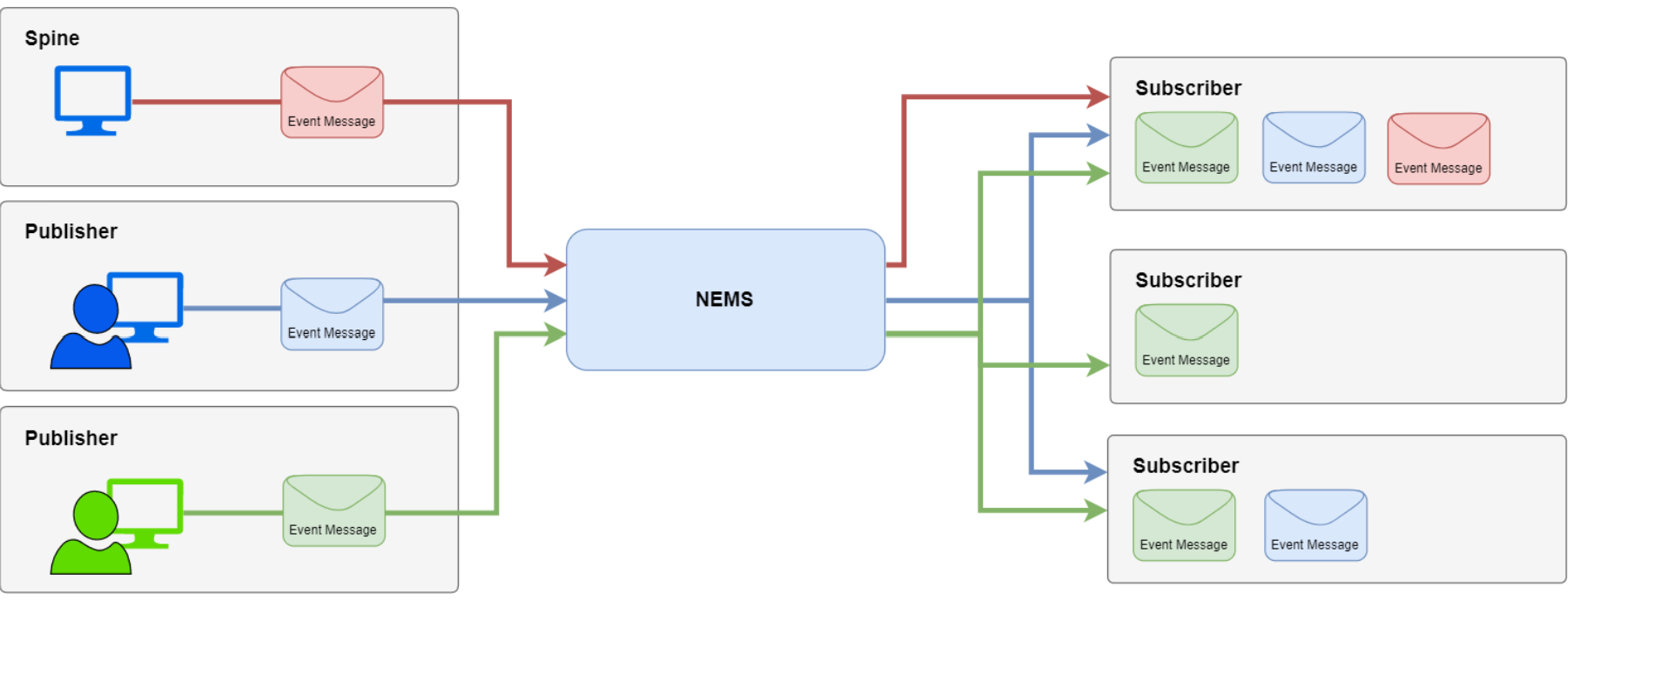

Figure 2 – High Level NEMS Flow

## NEMS Data Flow



Figure 3 - NEMS Data Flow Diagram

## NEMS Eligibility

As the National Event Management Service is a data-sharing capability, governance and assurance controls exist to ensure that only eligible health and social care organisations wishing to publish or subscribe to NEMS are approved to do so.

These controls ensure that information sharing requests are in keeping with NHS Digital’s information governance requirements and the DIP Direction.

Requests to publish or subscribe to existing events or to share new or changed ‘information flows’[5] are managed through the Interoperability Working Group and are triggered by the submission of an Information Flow Request form (available via: [LS.iwg@nhs.net](mailto:LS.iwg@nhs.net)).

Requests are assessed by a multidisciplinary team with representation from the business, clinical safety, information governance and technical architecture to determine:

* Validity of the sharing request
* Necessity, proportionality, and lawful basis
* The organisation’s and it’s end user’s appropriateness for the sharing of the information
* Appropriate architectural pattern to apply based on the end user needs

The current scope of the Working Group is the National Events Management Service (NEMS) and the National Record Locator (NRL) service, other capabilities and services may be brought under the remit of the Working Group in the future.

## NEMS Principles

* Genericity of events is maintained where possible to support reuse across eligible health and social care systems.
* New or changed requests to share information are fit for use and fit for purpose by users
* Use of NEMS
  + - Aligns to the architectural principles
    - Is underpinned by the appropriate information governance artefacts
    - Supports clinical safety
    - Is for direct care purposes

## NEMS Prerequisites

The pre-requisites are contained in detail in the Supplier Conformance Assessment List (SCAL) as are the business requirements, however key items have been summarised here to help connecting parties identify potential showstoppers at an early stage.

**Technical**

1. PDS Compliancy. For information about searching using demographic information see <https://digital.nhs.uk/services/demographics>
2. Penetration Testing
3. A valid ODS (Organisation Data Service) code is required for the connecting party). The ODS Portal indicates if an organisation has a registered code: <https://odsportal.hscic.gov.uk/Organisation/Search>
4. N3 or HSCN connection. This is required for both live service and the online testing process.
5. A valid NHS Smartcard for all users or a system that uses an authentication method supported by NHS Identity or NHS Login. For more information about SmartCards, see <https://developer.nhs.uk/apis/spine-core/smartcards.html>

**Information Governance**

1. An organisation must have completed the DSPT (Data Security Protection Toolkit) within the last 12 months (<https://www.dsptoolkit.nhs.uk>).

**Clinical Safety**

1. Connecting parties must have an appointed Clinical Safety Officer and undertake a Clinical Safety Assessment prior to going live.

# NEMS Functionality

## Overview

An approved organisation may be a NEMS publisher, subscriber or both, the functionality to be developed is summarised as:

* NEMS Subscription API
  + Creation and deletion of subscriptions
  + Auditing of the management of subscriptions
  + Verification of NHS number prior to subscription creation
  + Conformance to the Information Governance requirements
* NEMS Publisher
  + Auditing of the published messages
  + Verification of NHS number prior to publishing
  + Conformance to the specific event construction and content
  + Conformance to the Information Governance requirements
* NEMS Event Receiver
  + Audit of message processing
  + Audit of user access to the data received
  + Conformance to the Information Governance requirements

|  |  |  |  |
| --- | --- | --- | --- |
| Key Technical Requirements | NEMS Subscription | NEMS Publisher API | NEMS Event Receiver |
| Subscription API Capability | Publish API Capability | Generic Subscription Capability |
| PDS Compliant | l | l |  |
| Endpoint Registration | l | l |  |
| MESH Configuration | l |  | l |

The NEMS technical specification provides further detail and the requirements, it is located on the Health Developer Network: [National Event Management Service Technical Specification](https://developer.nhs.uk/apis/ems-beta/).

## Generic Event Messages

Each event message which passes through NEMS carries a standard set of event information to allow the receiver of the message to identify:

* the patient who is the focus of the event
* information about the provider who published the event message, including [contact details](https://developer.nhs.uk/apis/ems-beta/overview_msg_architecture_feedback.html) for issues with the event message
* information about the event that occurred
* information to allow receivers to perform [message sequencing](https://developer.nhs.uk/apis/ems-beta/overview_msg_architecture_sequencing.html)

Generic event messages are designed and intended for reuse across different organisations and care settings.

### Event Maturity

The maturity of an event message is indicated in the following tables, event maturity labels are intended to indicate the expected stability of the event messages.

|  |  |
| --- | --- |
| Event Maturity | Description |
| Alpha | Early proposal for an event message, high risk of change. |
| Beta | The event design has been agreed and is intended to become the release candidate but has not been proved through development and testing, therefore there is a risk that changes may be required. |
| Release Candidate | The event has been through a development and testing phase, followed by a successful Deployment Verification Period[6] (DVP) in live use. The event message should not change unless as a result of a live issue. |
| Released | Event is being widely used and is unlikely to change, unless a change is required as a result of a live issue. |

Table 3: Event Maturity Labels

### Supported Generic Event Messages

The following are generic event messages supported by the NEMS.

| Event | Event Code | Publication API | Subscription API | Date Available | Event Maturity |
| --- | --- | --- | --- | --- | --- |
| [PDS Birth Notification](https://developer.nhs.uk/apis/ems-beta/pds_birth_notification.html) | pds-birth-notification-1 | ❌ | ✅ | March 2019 | Release Candidate |
| [PDS Change of Address](https://developer.nhs.uk/apis/ems-beta/pds_change_of_address.html) | pds-change-of-address-1 | ❌ | ✅ | March 2019 | Release Candidate |
| [PDS Change of GP](https://developer.nhs.uk/apis/ems-beta/pds_change_of_gp.html) | pds-change-of-gp-1 | ❌ | ✅ | March 2019 | Release Candidate |
| [PDS Death Notification](https://developer.nhs.uk/apis/ems-beta/pds_death_notification.html) | pds-death-notification-1 | ❌ | ✅ | March 2019 | Release Candidate |
| [Professional Contacts](https://developer.nhs.uk/apis/ems-beta/professional_contacts_1.html) | professional-contacts-1 | ✅ | ✅ | May 2020 | Beta |
| [Vaccinations](https://developer.nhs.uk/apis/ems-beta/vaccinations_1.html) | vaccinations-1 | ✅ | ✅ | May 2020 | Beta |

Table 4: Generic NEMS Event Messages

### Digital Child Health Event Messages

The following event message are supported by the NEMS but have been defined by Digital Child Health.

|  |  |  |  |  |  |
| --- | --- | --- | --- | --- | --- |
| Event | Event Code | Publication API | Subscription API | Date Available | Event Maturity |
| [Blood Spot Test Outcome](https://nhsconnect.github.io/Digital-Child-Health-CareConnect/explore_blood_spot_test_outcome.html) | blood-spot-test-outcome-1 | ✅ | ✅ | October 2019 | Release Candidate |
| [Newborn Hearing](https://nhsconnect.github.io/Digital-Child-Health-CareConnect/explore_newborn_hearing.html) | newborn-hearing-1 | ✅ | ✅ | October 2019 | Release Candidate |
| [NIPE Outcome](https://nhsconnect.github.io/Digital-Child-Health-CareConnect/explore_nipe_outcome.html) | nipe-outcome-1 | ✅ | ✅ | October 2019 | Release Candidate |

Table 5: DCH Specific Event Messages

## Publishing

The following process outlines the high-level business process for the publishing of events to the National Event Management service.

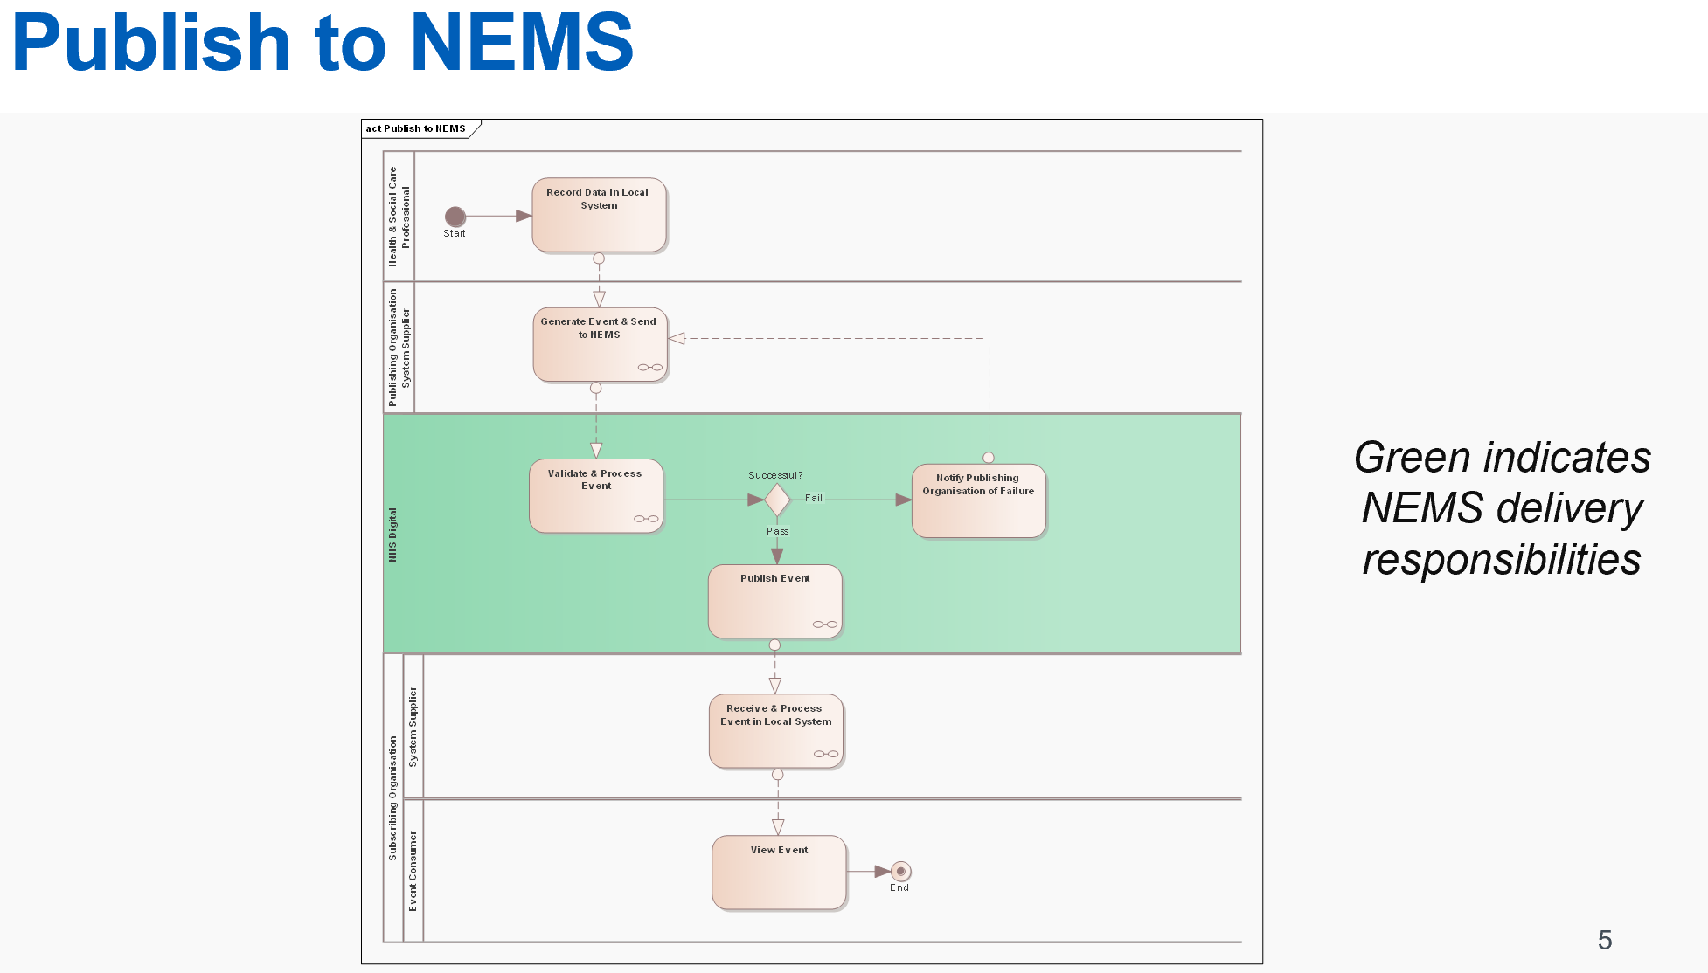

Figure 4: Publishing to NEMS Process

## Subscribing

The following process outlines the high-level business process for subscribing to events from the National Event Management service.

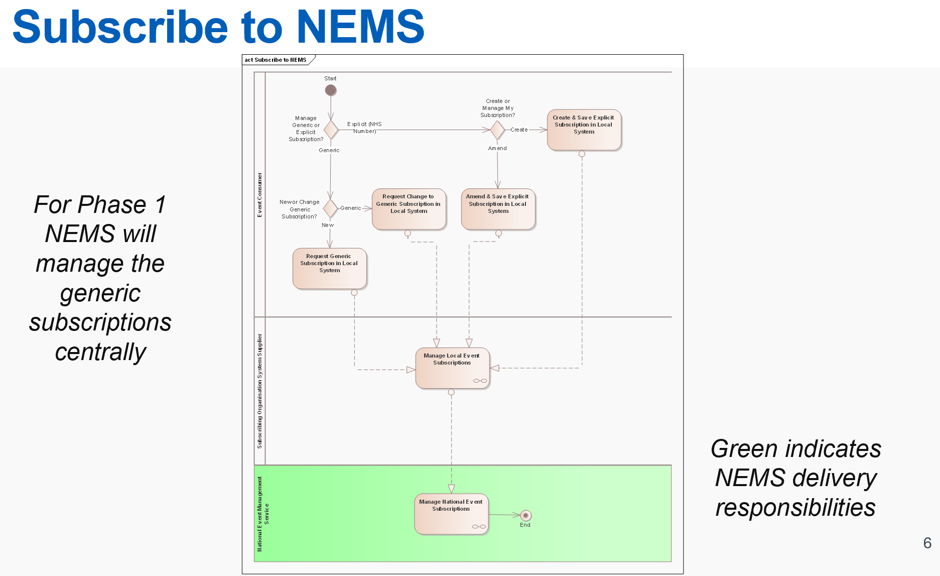

Figure 5: Subscribing to NEMS

## Subscriptions Management

The current manual process of reviewing and processing subscription requests for the creation of generic subscription requests in the National Event Management service is not long-term sustainable or efficient for NHS Digital – the following outlines the current process.

The long-term plan is the development of the strategic solution which will support self-service in the creation and management of subscriptions and allow suppliers and end users to create their own generic and explicit subscriptions.

### Explicit Subscriptions

An explicit subscription relates to where a subscriber wishes to receive event messages for a specific patient, for example, a Pharmacist wishing to receive hospital admission and discharge events for a specific Patient.

Explicit subscriptions should only be active for patients under the subscribing organisation’s direct care. Explicit subscriptions for a patient should be stopped when the patient leaves the subscribing organisation’s direct care.

### Rule-Based (Generic) Subscriptions

Rule-based subscriptions relate to where a subscriber wishes to receive events that meet a particular rule set rather than for a specific patient. There are currently two specific types of rule-based subscriptions:

* **Geographical**: Subscriptions that relate to individuals who live in or are registered with a GP that is located within the geographic boundaries of a specific organisation (For example, a Health Visiting Service wishing to view events for all children within a specific local authority’s area of responsibility).

A geographical rule-based subscription will result in a subscriber receiving events for any patients within the specified geographical area, therefore a subscriber wishing to use this form of subscription must have a legitimate relationship with all patients in the area. If a provider is only responsible for a subset of patients within a geographical area, then geographical subscriptions are not appropriate as the provider will receive information for patients with which they do not have a legitimate relationship. In this scenario the provider should use explicit subscriptions to receive events for the patients with which they have a legitimate relationship.

* **Registered Org**: Subscriptions that relate to individuals who are registered with a specific organisation (currently only applicable for GP organisations).

The following rule types are currently available for use within Generic Rule Based Subscriptions and the detail of the rules can be found in the Appendix:

| Rule Name | Details |
| --- | --- |
| Patients Postcode within CCGs area of responsibility (Residential CHO) | * NEMS matches the patient’s home postcode, from their PDS record, to a specific CCG based the areas of responsible for the different CCGs. * NEMS then looks for generic subscription rules which contain a CCG Code that matches the CCG responsible for the area in which the patient’s postcode resides. * A copy of the event message is sent to the mailboxes specified in those matching generic subscriptions. |
| Patient’s Registered GP is a child of the CCG (CHO of registration) | * NEMS looks up the patients registered GP within their PDS record, then finds the parent CCG for that GP practice. * NEMS checks the generic subscriptions for any rules which contain a CCG Code that matches the parent CCG of the patients GP. * A copy of the event message is sent to the mailboxes specified in those matching generic subscriptions. |
| Patient’s Registered GP Code matches GP Code (GP) | * NEMS matches the patients registered GP Code, from their PDS record, to generic subscription rules which contain the same GP Code. * A copy of the event message is sent to the mailboxes specified in those matching generic subscriptions. |
| Patient’s’ Postcode within LA’s area of responsibility (HVS) | * NEMS matches the patient’s home postcode, from their PDS record, to a specific LA based the areas of responsible for the different LAs. * The NEMS then looks for generic subscription rules which contain an LA Code that matches the LA responsible for the area in which the patient’s postcode resides. * A copy of the event message is sent to the mailboxes specified in those matching generic subscriptions. |
| All Patients in England (HSS) | * NEMS matches all patients who live in England to generic subscription rules which specify the rule type of National. * A copy of the event message is sent to the mailboxes specified in those matching generic subscriptions. |

# Testing and Technical Conformance

## Technical Conformance Testing Guidance

When ready to commence assurance activities, please contact the NEMS team direct via [nrlnems@nhs.net](mailto:nrlnems@nhs.net) where the team will:

* Assess suitability for NEMS (See section 2.3 for further information).
* Detail the required NEMS Assurance stages to complete
* Ensure pre-requisites are met.
* Verify plans for development.
* Advise on next steps to begin testing.
* Issue the latest version of the Supplier Conformance Assessment List (SCAL) that is tailored to reflect any previous conformance testing undertaken with NHS Digital.

## NEMS Assurance Stages

When an organisation begins onboarding to NEMS, they will be required to carry out assurance and testing activities through the following stages:

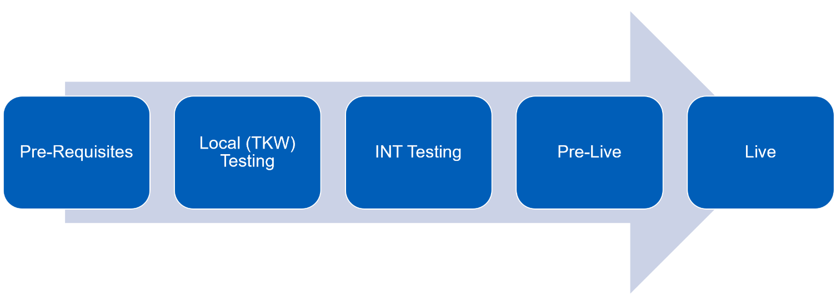

**Pre-Requisites**

The team will verify that the organisation wishing to onboard to NEMS meets the basic entry criteria to use the product, and will have received guidance from the IWG to ensure that NEMS is the appropriate route to provide the service (refer to section 2.3).

To use the service organisations MUST have most of these pre-requisites in place prior to starting development activities and have received approval from the IWG to proceed with NEMS.

**Note:** The Developer site provides materials enabling organisation to begin local testing activities, but the NRL team can accept no responsibility in the event that permission to proceed with onboard with NRL is rejected.

Therefore, any activities carried out without meeting these requirements is the risk of the organisation.

**Local (Toolkit Workbench - TKW) Testing**

Following completion of pre-requisites activities, the team will grant authority to proceed Local (TKW) Testing activities.

This involves working with the NHS Digital Solutions Assurance team who will arrange setup of the *Opentest* environment and provide test scripts to carry out the TKW required activities.

During this stage you will also receive a copy of the SCAL. Further guidance on completing this is available in section 5.1.1

To proceed to INT testing, the organisation MUST demonstrate they can validate messages against the TKW as per the NHS Digital Solutions Assurance team requirements.

**INT testing**

The NHS Digital INT Environment is a *sandbox* environment for testing the functionality to NEMS and a pre-test to ensure that the organisations development is safe to use on the Live Spine environment.

Access to the INT environment will be setup prior to completing TKW activities to avoid delays. Details on requesting setup to INT can be found in section 4.3.

The organisation will continue working with the NHS Digital Solutions Assurance team executing the test system cases provided.

Upon reaching this stage *‘cat bag’* codes will be issued (Contact [nrlnems.ls@nhs.net](mailto:nrlnems.ls@nhs.net) to receive these).

The types issued are subjective to what event types and subscription types have been approved at IWG.

‘Cat bag’ properties are used on a user’s ASID to determine what events a user is permitted to subscribe to, and what kinds of subscriptions a user is permitted to create.

Once the Solutions Assurance team are satisfied the test requirements are met a Technical Conformance Certificate (TCC) will be issued to confirm suitability for go-live.

Further updates are made to the SCAL in reflection of these activities.

**Pre-Live**

Before an organisation is granted access to a live environment they would be expected to sign:

* A Connection Agreement (For Publishers)
* Data Sharing Arrangement (DSA) (for *subscribers*)

**Note:** to avoid delays to go-live these agreements maybe provided earlier.

The organisation will also run through a Go-No Go Checklist with the NEMS team to ensure all requirements have been met.

**Live**

With all assurance requirements complete, the organisation moves NEMS into business as usual activities.

For further support while live please see section 7.

## Connecting to the NHS Digital Integration (INT) Environment

### Instructions for End Point Registration (EPR) in the INT environment

The following section provides the basic steps for connecting to the INT environment for the specific purpose of undertaking conformance testing with NEMS.

Further levels of detail, including generic guidance for how to connect to the NHS Digital INT environment can be found on the [NHSD Path to Live](https://digital.nhs.uk/services/path-to-live-environments/integration-environment) intranet pages.

The following should be noted when reading the above linked guidance, specifically for the purposes of Conformance Testing with NEMs:

* Requesting access to test data is not required for conformance testing with NEMs.
* Whilst Smartcards are a requirement to consume NEMs as a subscriber in the Live environment, they are not necessarily required to complete conformance testing with the NEMs in the INT environment. Similarly, Identity Agent client software is not necessarily required to complete conformance testing with the NEMs in the INT environment.

Any questions or request for support should be addressed to the NHS Digital Platforms Support Desk: [platforms.supportdesk@nhs.net](mailto:platforms.supportdesk@nhs.net)

1. **Register Messaging Product**

<https://digital.nhs.uk/forms/manufacturer-product-version-registration-request>

Use the above link to provide the product name and version, organisation name and ODS code, which will be registered in the INT environment.

1. **Create endpoint and certificate:**

<https://digital.nhs.uk/forms/combined-endpoint-and-service-registration-request>

In order to complete the End Point Registration to the Integration (INT) Sandpit Environment, a Certificate Signing Request (CSR) must be provided and contain the following:

* Keylength: 2048
* CN (Common Name): ***the FQDN***
* Country Code:GB

All other details should be left blank.

NHS Digital has experienced problems in the past when creating a CSR using SSL Win-32 so it is recommended that SSL Win-64 is used. All certificates that are to be used to connect to the spine must have a distinguished name that contains a CN, or Common Name.

1. **Register the Fully Qualified Domain Name (FQDN) with the NHS DNS team:**

<https://digital.nhs.uk/forms/dns-request-form-for-path-to-live-environments>

Provide the HSCN-facing IP address, (with an appropriately formatted test FQDN), so that it can be registered on the NHS Digital DNS.  
Note that the following requirements for endpoints must be met:

* 1. The FQDN must end in nhs.uk
  2. Endpoints must be on port 443
  3. Endpoints must not include explicit port declarations (e.g. :443)

1. **Configure Firewalls:**

Make sure firewalls allow appropriate inbound and outbound messages. The next section (INT Environment Connection Details for NEMS) will be of assistance.

1. **Complete Local Environment Setup:**

Once NHSD has the CSR and the Service Registration has been completed the Party Key will be sent, ASID and digital certificate to enable connection to the INT environment for the final tests.

### INT Environment Connection Details for NEMS

1. NEMS URL:

For subscription

<https://msg.int.spine2.ncrs.nhs.uk/STU3/Subscription>

For events like NIPE outcome, new born, blood spot etc (Digital Child Health events).

<https://msg.int.spine2.ncrs.nhs.uk/STU3/Events/1/$process-message>

IP Address: 10.239.14.26

1. Port: 443 TCP
2. Spine Party Key: YES-0000806
3. NEMS ASID: 200000000306
4. SSP Proxy URL: proxy.int.spine2.ncrs.nhs.uk
5. IP Addresses:  10.239.14.31
6. Port: 443 TCP
7. LDAP URL**: ldap.nis1.national.ncrs.nhs.uk
8. IP Address: 10.196.94.141
9. Port: 636 TCP

**Note:** When setting up connection with NEMS, the connecting supplier system should use the NEMS URL and NOT the NEMS IP Address. This is because NEMS is setup with a primary and secondary server in the spine, both which have separate IP Addresses.

Therefore, the supplier system should not be hard coded to connect to the NEMS IP Address, otherwise this will result in connection issues should the spine failover.

# Onboarding Artefacts

There are several key artefacts that support Technical Conformance and the integration with NHS Digital Services:

* Supplier Conformance Assessment List (SCAL)
* Connection Agreement (CA)
* Technical Conformance Certificate (TCC)
* Data Sharing Arrangement (DSA)

## Supplier Conformance Assessment List and Technical Conformance Certificate

The purpose of the Supplier Conformance Assessment List (SCAL) is for a product supplier (or End User Organisation (EUO) if developing an 'in-house' product) to declare and record that it meets or complies with a range of organisational, technical (product) and compliance requirements including those for Information Governance and Security, Clinical Safety and individual user interaction.

The information provided in the SCAL helps EUOs to assure themselves that the Product has been developed according to various quality and compliance requirements and standards. Any queries about the information provided in the SCAL is the developing party’s responsibility to address.

The SCAL underpins the technical conformance process and is referenced in the Connection Agreement (CA) that every Supplier must sign before their Product can connect to NHS Digital Service(s).

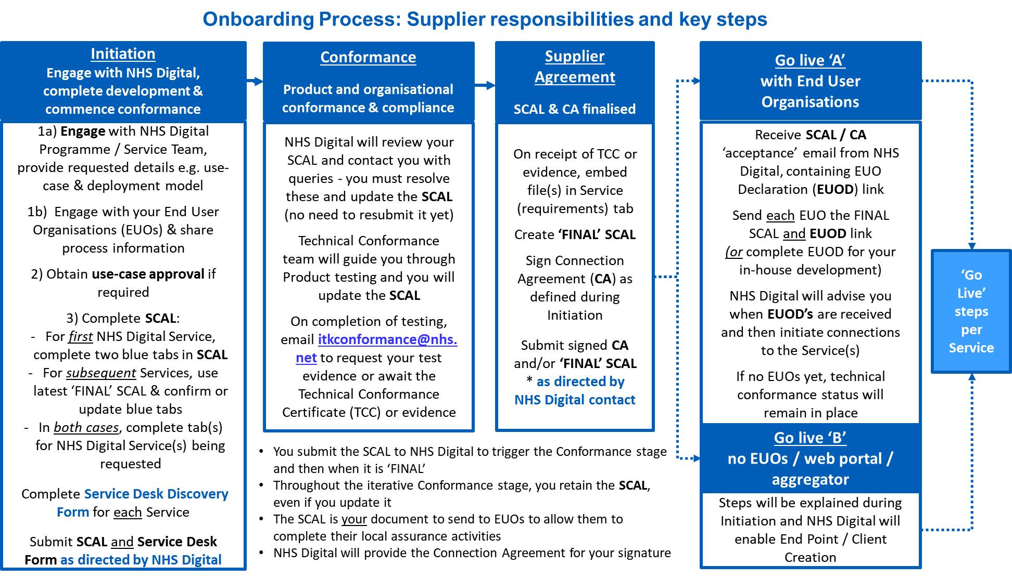

Figure 6 - Supplier Connection Assessment List

A SCAL is per (supplier) product, however the a single SCAL can cover integration to more than one NHS Digital Service.

* Maps all the requirements needed to interface with a specific service and the evidence required during technical conformance process and is supplier / product focussed.
* Within the SCAL, the connecting party logs where a product meets the technical, information governance and clinical safety requirements in a technical and business context.
* Many sections of the SCAL can be completed in parallel to the testing so it is recommended that all connecting parties familiarise themselves with the SCAL as early in the process as possible.
* On successful completion of the SCAL process a Technical Conformance Certificate (TCC) is issued

### Already completed a SCAL?

There are two approaches to completing this document, dependent on whether the organisation has already completed a SCAL for an NHS Digital product.

* *If the organisation has previously completed a SCAL for an NHS Digital product*: the organisation will need to **update** the *‘General’* and *‘Architecture’* tabs and **complete** the required NEMS tabs.
* *If the organisation has NOT completed a SCAL for an NHS Digital product*: the organisation will need to **complete** the *‘General’* and *‘Architecture’* tabs, **and** the required NEMS tabs.

**Note:** The SCAL is a working document and will be updated throughout the stages to reflect testing activities and evidence.

The SCAL contains guidance to help populate the required information to complete assurance requirements for onboarding.

## Connection Agreement

* Agreement formed between the Supplier (connecting party) and NHS Digital. comprises of a set of terms and conditions, links to the SCAL, and any Special Terms for a service and exists as an agreement for the duration of connection to the service.
* References End User Organisations and Individual End User obligations.
* Only needs to be completed by organisation directly connecting to NHS Digital systems.

## Data Sharing Arrangement

Controllers are also expected to sign a Data Sharing Arrangement (DSA) that sets out their data protection responsibilities as controller for the event message, either as subscriber or publisher.

# Live Service Implementation

## Live Connection Request

Once the following activities have been completed, live connection details can be requested from the onboarding lead ([nrlnems@nhs.net](mailto:nrlnems@nhs.net)).

1. Technical Conformance Testing Completed by Supplier
2. SCAL completed by supplier and accepted by NHS Digital
3. Connection Agreement signed and returned by Supplier
4. Data Sharing Arrangement completed by End User Organisation

## Supplier Access to NEMS Process



# Post Implementation Support

As the National Event Management Service does not look at the content of an event where there are issues with:

|  |  |  |
| --- | --- | --- |
| Scenario Title | Summary | Expected Outcome |
| Clinical Data Quality / Content | Issues with the quality or content of the data e.g. incorrect codes used | * Local discussion with the Publishing Organisation to address issues * No NHSD involvement |
| Event Message Structure | Unable to consume events in the local system | * Initial local investigation and diagnosis completed to determine if:   + Aligns to latest version of FIHR profile   + Certificate has expired * Not expected that this would require NHSD involvement |
| Event Subscriptions | I do not know who this person is | * Initial local investigation and diagnosis completed to determine if:   + Subscriptions are accurate   + May require NHSD involvement following local investigation and diagnosis |
| Event Disruption | I’ve stopped receiving events for a patient I have a legitimate interest | * Initial local investigation and diagnosis, reasons may include: * S Flag has been applied in PDS (events are not sent) * Subscription may have failed / become corrupted |

## Incident Management



NHS Digital National Service Desk:

* Tel: 0300 3 035 035
* Email: [ssd.nationalservicedesk@nhs.net](https://hscic365.sharepoint.com/sites/IP/National%20Record%20Locator%20Phase%202/Requirements/Processes%20and%20Guidance/ssd.nationalservicedesk@nhs.net)
* [Weblog](https://nww.serviceportal.digital.nhs.uk/CherwellPortal/NHSD#0) – Account Creation Required (see guide)



## Environment Maintenance

During the onboarding process, all connecting parties will be added to the Platforms Support Newsletter distribution list. The newsletter informs users of forthcoming changes to the NEMS Service that are deployed to the NEMs test environments (this is currently the Integration environment and referred to as INT for short) prior to Live.

If these newsletters are not received in the first two weeks following go-live, contact the Platforms Support Desk ([platforms.supportdesk@nhs.net](mailto:platforms.supportdesk@nhs.net)) to request to be added to the distribution list.

# Appendix

## NEMS Business Rules

### PDS Birth Notification



### PDS Change of Address



### PDS Change of GP



### PDS Death



### Newborn Infant Physical Examination



### Bloodspot Outcome



### Hearing



### Professional Contact



### Vaccinations



## NHS Digital Onboarding Supplier Task Checklist

The following activities are listed in an approximate chronological order as a guide only, to be tailored according to local working practices and processes:

1. Assign key resources to the project including:
   1. Primary Contact (e.g. project manager)
   2. Technical lead and/or developer(s)
   3. IG lead
   4. Clinical lead
2. All key resources to Review Onboarding Documentation.
3. Confirm Delivery Approach.
4. Commence Product Development.
5. Commence activities listed in SCAL
6. Commence any applicable local clinical safety assessments / processes.
7. Test development against reference implementation.
8. Complete TKW.
9. Complete Conformance Testing (NHSD Test Environment).
10. Update Business Processes and Train Users.
11. Obtain all necessary local approvals for go-live (e.g. clinical safety, board approvals).
12. Sign NHS Digital relevant commercial documents
13. Undertake implementation with NHS Digital.

## Frequently Asked Questions

|  | FAQ | Response |
| --- | --- | --- |
|  | Where can I find the business requirements? | <https://developer.nhs.uk/apis/ems-beta/> |
|  | We have received an event and there are data quality issues, why won’t NHS Digital look at the content of an event when there are? | NHS Digital does not have the authority to view the events, issues with content must be discussed with the publisher. |
|  | Where can I see who is subscribing to which events? | The NEMS Data Controller Catalogue provides a current and forward view of NEMS publishers and subscribers.  The purpose of the controller catalogue is to document the system suppliers and health and social care organisations authorised to share information as events using the National Events Management Service (NEMS).  Any requests to share information via NHS Digital services, the source and consumer of that information, are reviewed by the Interoperability Working Group and a recommendation provided by the group as to the appropriate sharing pattern(s) and sharing capability(ies) which meet end user needs.  <https://developer.nhs.uk/apis/ems-beta/controller_catalogue.html> |
|  | Why do we have to complete the SCAL for each new event? | Each new event requires a retest of some (not all) of the requirements. Additionally, as each new event carries new data it is important to test that events are managed in the expected way. |
|  | Why is PDS compliancy required to be able to publish or subscribe to NEMS? | To validate and verify that subscriptions are correct, and events are correctly published. |
|  | Can NEMS be used in conjunction with the National Record Locator? | Yes it can where this meets the business needs. |

1. https://digital.nhs.uk/about-nhs-digital/corporate-information-and-documents/directions-and-data-provision-notices/secretary-of-state-directions/establishment-of-systems-digital-interoperability-platform-2019#purpose
2. A clinical, social or public health activity concerned with the prevention, investigation and treatment of illness and the alleviation of suffering of individuals. It includes supporting individuals’ ability to function and improve their participation in life and society. It includes the assurance of safe and high quality care and treatment through local audit, the management of untoward or adverse incidents, person satisfaction including measurement of outcomes undertaken by one or more registered and regulated health or social care professionals and their team with whom the individual has a legitimate relationship for their care. (Source: https://www.gov.uk/government/publications/the-information-governance-review)
3. <https://developer.nhs.uk/>
4. An organisation which has completed the NHS Digital Interoperability Working Group and a recommendation that the use of NEMS best meets the user needs.
5. The term information flow is used to delineate between the initial request to share information and the IWG’s recommended architectural pattern e.g. event (and there NEMS) or record pointer (and therefore the National Record Locator (NRL))
6. Agreed period of stability